**Remote Controller**

**User Manual**

**Turn off**

**Turn on**

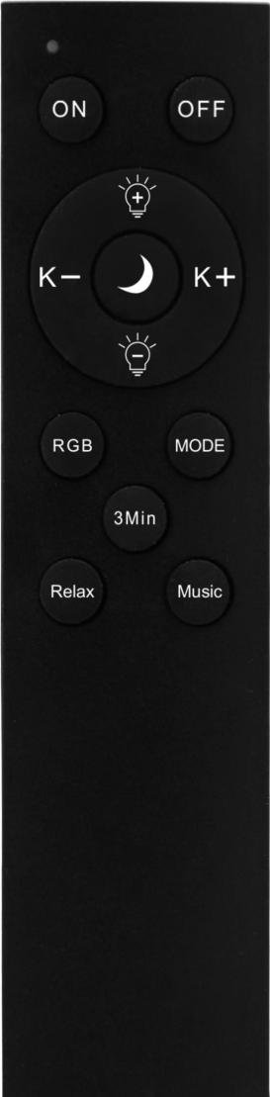

**A.Short Press to increase the brightness 20% per time**

**B.Long press to increase the brightness smoothly**

**Night Light，5% Brightness，Warm-white**

**A.**

**A.Short Press to increase the CCT 20% per time**

**B.Long press to increase the CCT smoothly**

**A.Short Press to decrease the CCT 20% per time**

**B.Long press to decrease the CCT smoothly**

**A.Short Press to decrease the brightness 20% per time**

**B.Long press to decrease the brightness smoothly**

**Short Press to change the lighting mode: Up lighting, Down lighting and Up & Down lighting.**

**RGB mode, RGB vivid color only. Press K- / K+ to change RGB vivid colors**

**Timing Switch of the lamp by 3 mins**

**RGB Rhythm mode**

**RGB Relax Mode for music**